Project Plan
AI Cassette Inspection Platform
Trymax Semiconductor Equipment B.V., Nijmegen
Date | February 2026
Version | 1.0
Status | Draft
Author | Anton Horvat

Version History
Version | Date | Author | Amendments | Status
1.0 | Feb 2026 | Anton Horvat | Initial version | Draft

Communication
Version | Date | Sent to
1.0 | Feb 2026 | Company supervisor, School supervisor

Table of Contents
Table of Contents 1
1. Project Assignment 1
1.1 Context 1
1.2 Goal of the project 1
1.3 The assignment 1
1.4 Scope 1
1.5 Conditions 1
1.6 Finished products 1
1.7 Research questions 1
2. Approach and Planning 1
2.1 Approach 1
Test approach 1
2.2 Research methods 1
SQ1: Visual features per slot state 1
SQ2: CNN architecture selection 1
SQ3: Dynamic cassette size handling 1
SQ4: Grad-CAM for engineer trust 1
SQ5: Self-improving loop design 1
SQ6: Dark room camera solutions 1
SQ7: Multi-camera architecture 1
2.3 Learning outcomes 1
1. Professional Duties 1
2. Situation-Orientation 1
3. Professional Standard 1
4. Personal Leadership 1
2.4 Breakdown of the project 1
2.5 Time plan 1
3. Project Organization 1
3.1 Team members 1
3.2 Communication 1
3.3 Test environment 1
3.4 Configuration management 1
4. Finance and Risks 1
4.1 Cost budget 1
4.2 Risks and fall-back activities 1
5. Other 1

(Right-click > Update Field in Word)

1. Project Assignment

1.1 Context
Trymax Semiconductor Equipment B.V. is based in Nijmegen and builds plasma-based machines for the semiconductor industry. Their NEO series (UV and 2000 variants) is used worldwide for processes like plasma etching and UV curing. The company currently has over 500 process chambers installed and is scaling towards 1,000 by the end of 2025.
Inside these machines, wafers are transported in cassettes. Each cassette holds 25 wafers in separate slots. Before processing begins, the machine needs to know which slots contain wafers and whether any are misplaced. A mechanical mapper on the robot arm currently performs this check by moving through each slot one by one, taking 30 to 45 seconds per cassette.
Trymax operates two robot types. The UV series sends slot data directly in a standardized format called SlotOccupationState (values 0 through 6). The 2000 series uses a different raw format (values 0, 1, 2, 3, 4, 7, 8, 9) that the Trymax software translates into the same standard. Both types handle 6-inch and 8-inch cassettes, each with 25 slots.
My internship sits within the Trymax software team. I work alongside the developers maintaining the machine control software, and I have direct access to the machines, the engineers, and the existing data formats.

1.2 Goal of the project
The mapper is slow. At 30 to 45 seconds per cassette across hundreds of daily operations, the cumulative time loss adds up significantly. It also produces no visual output, so when something looks wrong, engineers have no way to verify what the mapper detected without running it again.
The goal is to build an AI-powered inspection platform that replaces or augments the mapper using camera-based computer vision. A camera captures an image of the cassette, and an AI model classifies all 25 slots in under one second. That is roughly 30 to 45 times faster.
Speed alone is not enough though. Engineers need to trust the AI before they rely on it. Every prediction therefore comes with a Grad-CAM heatmap showing exactly which part of the image the AI focused on. If the AI flags a slot as DoubleSlotted, the heatmap shows it detected two wafer edges. This visual transparency makes the system usable in practice.
The long-term vision is a platform that works across both robot types and cassette sizes, supports multiple cameras, and continuously improves by learning from every inspection. The self-improving loop means the AI gets better the longer it runs, eventually becoming accurate enough to replace the mapper entirely.

1.3 The assignment
Design and build an AI cassette inspection application that classifies 25 wafer slots from a camera image in under 1 second, supports both UV and 2000 series robots with 6-inch and 8-inch cassettes, provides explainable predictions through Grad-CAM, and includes a self-improving learning loop. The application is built once and scales from a laptop prototype to a multi-camera production system without needing to be rebuilt.

1.4 Scope
The project includes: | The project does not include:
AI model for 25-slot classification  Grad-CAM explainability  Application with 4 camera modes  Dynamic UV/2000 and 6/8-inch support  AI vs mapper side-by-side comparison  Self-improving loop design  API endpoint for Trymax software  Web dashboard for monitoring  Level 3 architecture design + handover docs | Purchasing production cameras  Modifying existing Trymax software  Full production deployment on all machines  Integration with ERP/MES systems  Support for non-25-slot cassettes  Camera mounting hardware design  Network infrastructure changes

The internship targets Level 2 (network-connected application on laptop) with Level 3 architecture fully designed for handover.
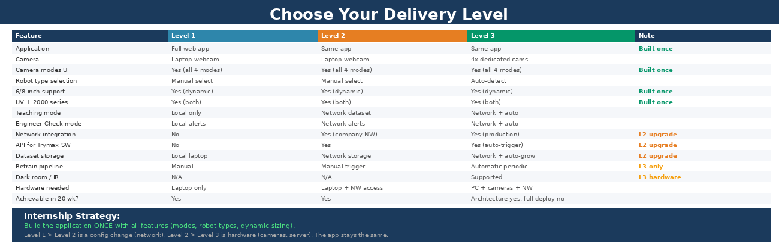

1.5 Conditions
Trymax uses PHP for their backend, so the integration layer will be in PHP. The AI itself runs Python with PyTorch and FastAPI. The company provides machine access for photography, software team availability for questions, and network access for Level 2. All code goes in Git. The prototype phase uses my iPhone for data collection and laptop webcam for live testing.

1.6 Finished products
- Plan van Aanpak (Week 2): Scope, levels, technical approach, and planning for Trymax.
- Project Plan (Week 2): This document, including DOT methods and learning outcomes.
- Dataset v1 (Week 3): Labeled photos of cassettes for both robot types and cassette sizes.
- Data Pipeline (Week 6): Scripts for loading, augmentation, ROI detection, and slot segmentation.
- Working AI Model (Week 10): Trained CNN with per-slot metrics and architecture comparison report.
- XAI Report (Week 14): Grad-CAM analysis, engineer validation results, mapper comparison data.
- Application (Week 17): Full app with camera modes, robot selection, Grad-CAM, and predictions.
- Network Integration (Week 18): Dataset on network, API endpoint, Teaching/Engineer Check over network.
- Level 3 Architecture (Week 19): Multi-camera design, hardware specs, deployment guide.
- Final Report + Handover (Week 20): Report, Git repo, presentation, knowledge transfer.

1.7 Research questions
Main question: How can a dynamic computer vision platform reliably classify 25-slot wafer cassettes across multiple robot types and cassette sizes in under 1 second, while providing explainable predictions and continuously improving through automated learning?

SQ1: What visual features distinguish Empty, CorrectlyOccupied, DoubleSlotted, and CrossSlotted across both UV and 2000 series?
SQ2: Which CNN architecture provides the best accuracy-to-speed tradeoff for real-time inspection?
SQ3: How can a single model handle both 6-inch and 8-inch cassettes dynamically?
SQ4: How effective is Grad-CAM at building engineer trust in AI predictions?
SQ5: How should Teaching Mode + Engineer Check be designed for continuous accuracy growth?
SQ6: What camera/lighting solutions work for dark room environments?
SQ7: What architecture allows scaling from 1 prototype camera to 4 production cameras?

2. Approach and Planning

2.1 Approach
I follow an iterative, phase-based approach. The project has 6 phases across 20 weeks. Within each phase I work in short cycles: build something, test it, get feedback, improve. This is not formal Scrum since I work solo, but I use weekly supervisor meetings as checkpoints and Friday status updates as rhythm.
Phases 1-2 (weeks 1-6) are orientation and data foundation. Phases 3-4 (weeks 7-14) are core AI development. Phases 5-6 (weeks 15-20) are application building, integration, and handover. I maintain a daily logbook and present to the team every 2-3 weeks.

Test approach
The AI model is evaluated with standard metrics: per-slot accuracy, confusion matrix, precision/recall, inference time. I use an 80/10/10 train/validation/test split. The application is tested end-to-end through the full workflow. The most important test is the live side-by-side comparison with the mechanical mapper on real cassettes.

2.2 Research methods
I use the DOT Framework (ictresearchmethods.nl) to ground my research. Each sub-question uses a mix of Field, Library, Lab, Workshop, and Showroom methods.

SQ1: Visual features per slot state
Method | How and why
Field | Observe cassettes at Trymax, photograph configurations, interview engineers about common faults.
Lab | Create intentional fault configs, photograph from multiple angles, analyze distinguishing features.
Library | Study existing literature on wafer defect detection and industrial quality inspection with CV.

SQ2: CNN architecture selection
Method | How and why
Library | Review papers comparing lightweight architectures (MobileNet, EfficientNet, ResNet) for industrial tasks.
Lab | Train multiple architectures on same dataset, compare accuracy, speed, and model size. Benchmark CPU vs GPU.
Workshop | Discuss results with software team to understand their performance constraints and preferences.

SQ3: Dynamic cassette size handling
Method | How and why
Library | Research multi-task learning and domain adaptation for handling different but related inputs.
Lab | Experiment: one mixed model vs separate models vs model with cassette-type parameter. Measure per-size accuracy.
Field | Photograph both sizes, ask engineers about frequency and fault patterns per size.

SQ4: Grad-CAM for engineer trust
Method | How and why
Library | Study Grad-CAM paper and XAI research in industrial settings.
Lab | Generate heatmaps for all states, measure if model focuses on wafer regions (not background).
Field | Show Grad-CAM to engineers, collect feedback on whether explanations make sense and build trust.
Showroom | Present results to team and stakeholders. Their reactions show if explanations work for non-AI people.

SQ5: Self-improving loop design
Method | How and why
Library | Research active learning, human-in-the-loop ML, and continuous learning best practices.
Workshop | Prototype Teaching/Engineer Check workflows with software team. Iterate on alert thresholds and retrain frequency.
Lab | Simulate the loop: incrementally add data, measure accuracy changes, test for regressions after retraining.

SQ6: Dark room camera solutions
Method | How and why
Field | Visit dark room machines, observe environment, ask engineers about lighting constraints.
Library | Research IR cameras, thermal imaging, LED ring lights for industrial low-light vision.
Lab | Test with different lighting (flashlight, LED, reduced ambient) to see impact on model accuracy.

SQ7: Multi-camera architecture
Method | How and why
Library | Study multi-camera system patterns: camera abstraction, microservices, concurrent feed handling.
Workshop | Co-design the architecture with software team so it fits their existing IPC and networking setup.
Showroom | Present architecture to team for review. They identify bandwidth, bottleneck, or compatibility issues.

2.3 Learning outcomes

1. Professional Duties
I perform Analysis (problem analysis, requirements, data analysis), Design (AI architecture, application UI, multi-camera design), Realize (trained model, working application, API), Advise (Grad-CAM findings, Level 3 recommendations), and Manage & Control (planning, status updates, risk management). Key evidence: working AI model, application, XAI report, architecture document.

2. Situation-Orientation
I work inside the Trymax software team, attending daily stand-ups and adapting to their tech stack (PHP, Windows IPCs). The assignment addresses a real business problem with real stakeholders. My approach is shaped by feedback from engineers, developers, and my supervisor. If the prototype works, Trymax plans to continue towards production.

3. Professional Standard
I own the project from problem analysis to delivery. Research uses DOT Framework methods with evidence-based decisions (e.g., CNN choice based on Lab experiments, not assumptions). Grad-CAM addresses AI ethics and EU AI Act transparency requirements. The self-improving loop and modular architecture are future-oriented choices ensuring long-term value.

4. Personal Leadership
I drive this project independently: making planning, identifying risks, seeking feedback proactively. I write weekly status updates and present to stakeholders. I chose to include the self-improving loop and multi-camera architecture even though they exceed minimum scope, because they make the project significantly more valuable. I reflect in my logbook and actively seek knowledge gaps.

2.4 Breakdown of the project
Phase | Weeks | Focus | Deliverable
1 | 1-3 | Onboarding, data collection (UV + 2000, 6-inch + 8-inch) | Labeled dataset
2 | 4-6 | Data pipeline, augmentation, ROI, dynamic slot segmentation | Pipeline scripts
3 | 7-10 | CNN training, architecture comparison, first Grad-CAM | Working model
4 | 11-14 | Optimization, robustness, XAI analysis, engineer validation | XAI report
5 | 15-17 | Application UI, camera modes, network integration | Application
6 | 18-20 | Testing, documentation, L3 architecture, handover, portfolio | Final report

2.5 Time plan
The phase breakdown above is the high-level plan. Weekly details are maintained through status updates. I reserve weeks 19-20 for documentation and portfolio. The iterative approach means exact boundaries between phases may shift based on findings.

3. Project Organization

3.1 Team members
Name | Abbr. | Role | Availability
Anton Horvat | AH | Intern, project lead | Full-time (20 weeks)
[Company Supervisor] | CS | Technical supervisor | Weekly meetings
[School Supervisor] | SS | Academic supervisor | Bi-weekly
Software team | SW | PHP integration, domain knowledge | Daily stand-ups

3.2 Communication
Meeting | Frequency | With | Purpose
Stand-up | Daily | Software team | Progress, blockers
Supervisor | Weekly | Company supervisor | Direction, feedback
School check-in | Bi-weekly | School supervisor | Academic progress
Status update | Friday | All | Written: done, planned, blockers

On-site 2-3 days/week (machine access, collaboration), remote 2-3 days (focused development).

3.3 Test environment
Development laptop with Python, PyTorch, OpenCV, FastAPI. Laptop webcam for live testing. Access to test machine at Trymax for mapper comparison. Company network access for Level 2 dataset storage and API testing.

3.4 Configuration management
Git repository with main/develop/feature branch strategy. Dataset versioned separately. Each model retrain creates a new version with logged metrics.

4. Finance and Risks

4.1 Cost budget
The prototype uses existing hardware and open-source software. No costs for Level 1 or 2. Level 3 hardware (cameras, production PC) would be a Trymax procurement decision post-internship. My week 19 architecture document will include specs and cost estimates.

4.2 Risks and fall-back activities
Risk | Prevention | Fall-back
Not enough training data | Transfer learning + augmentation. Teaching Mode grows dataset. | Focus on common states first. Add rare faults incrementally.
Model fails on one robot type | Collect data from both types from week 1. | Separate model heads per robot type if single model fails.
Supervisor unavailable | Weekly meetings. Software team backup. | Continue with team. Escalate to school supervisor.
Network access delayed | Request in week 1. Start with Level 1. | Deliver Level 1 first, upgrade when access granted.
20 weeks too short | Expected. Target Level 2 + L3 architecture. | Solid Level 2 with comprehensive handover docs.

5. Other
A few things that do not fit neatly into the sections above but are important for understanding this project:
Robot data format difference: The UV and 2000 series use different mapper formats. Trymax software handles the translation. My AI works exclusively with SlotOccupationState. I document the mapping but the translation is not my code.
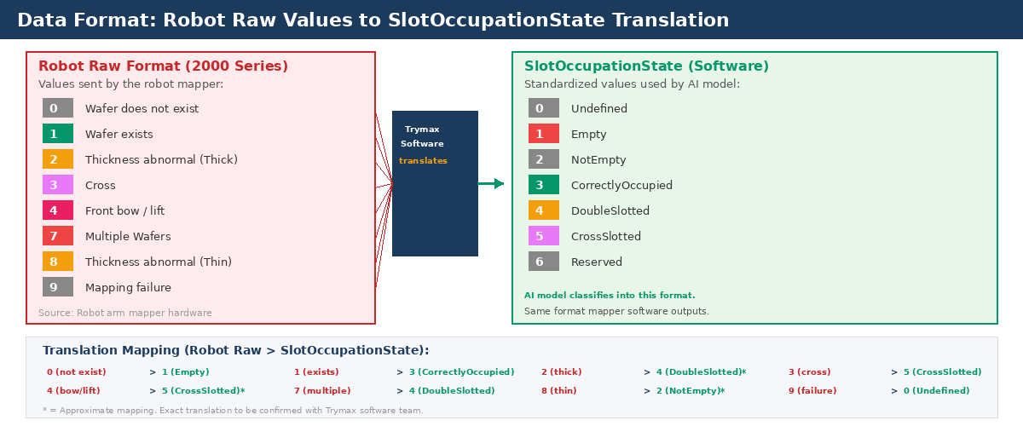
The self-improving loop: Teaching Mode and Engineer Check together create a cycle where the AI improves without manual labeling. The mapper provides ground truth automatically. Engineers only intervene on mismatches. Over time, fewer mismatches means less engineer workload and higher accuracy.
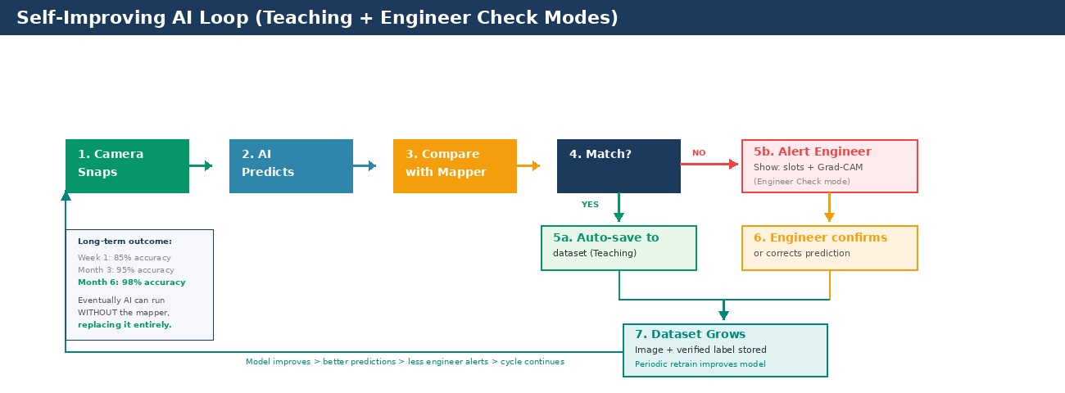
Application design: The application is built once with all features. Moving from Level 1 to 2 is a config change (enable network). Moving from 2 to 3 is hardware (cameras, server). This means no rebuilding, just deploying the same app on better hardware.
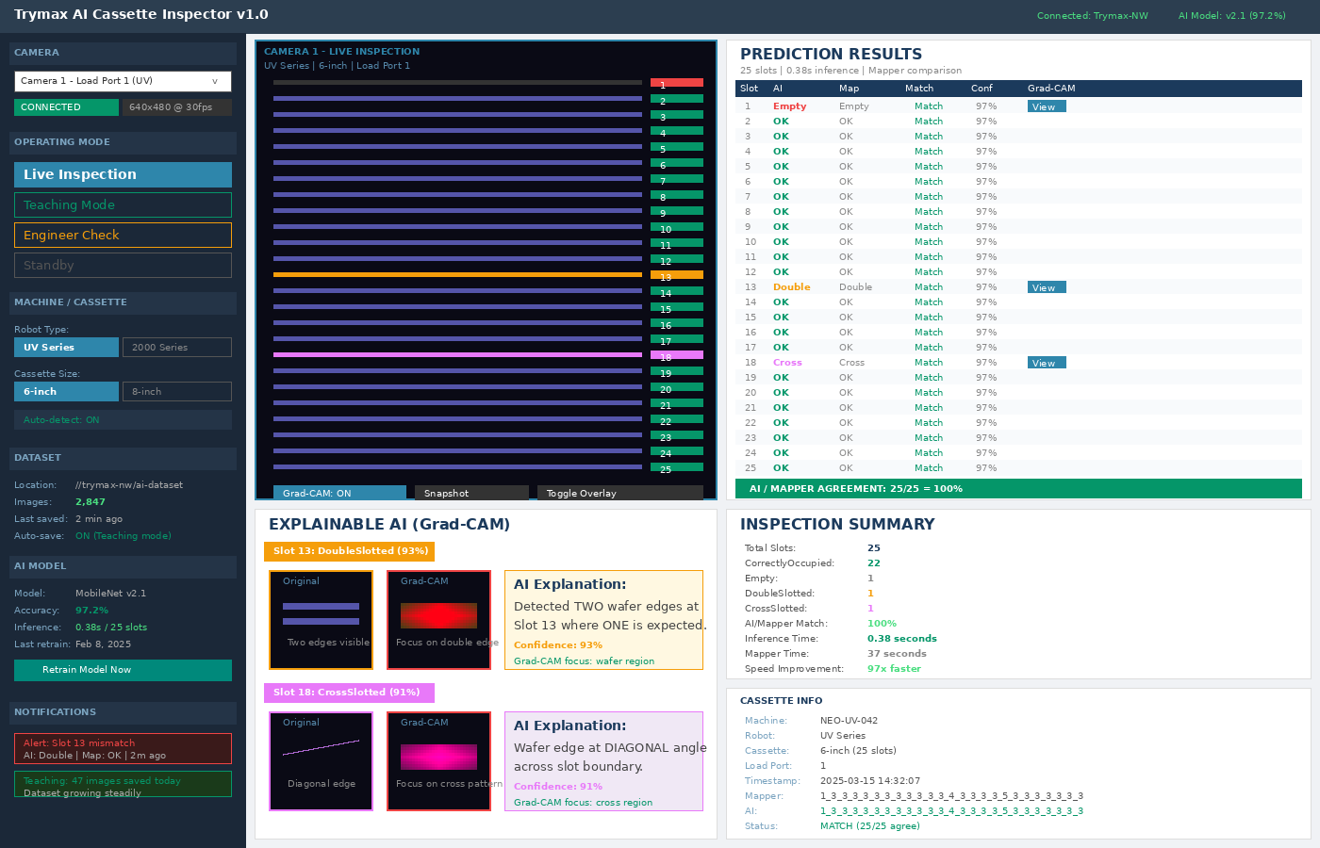
Camera operating modes: Four modes (Live, Teaching, Engineer Check, Standby) give operators control over what the camera does. This is designed for real production use where different machines need different modes at different times.
